

American International University- Bangladesh

CSC 3215: Web Technologies

CO1.1 and CO2.1 Evaluation

Project Report

Fall 23-24

Project Title: Healthcare Management System

Section: I

Group No: 6

|  |  |
| --- | --- |
| Student Name | Student Id |
| Mredul Mahmud Akash | 20-44257-3 |
| Md. Rifat Shikdar | 20-44202-3 |
| Md. Zamiul Sadik Nahin | 20-44228-3 |
|  |  |

Introduction:

*Welcome to our Healthcare Management System, a comprehensive solution designed to enhance the healthcare experience. This project aims to streamline patient care by providing doctors with seamless access to patient details, scheduling capabilities, article publication, and secure patient communication. Patients benefit from convenient access to reports, articles, and a virtual shop. By integrating these features, we aim to optimize healthcare processes, improve patient engagement, and foster a holistic approach to healthcare management.*

Background Study:

*To prepare this web application we have look up to some of the web applications that are owned by established hospital inside and outside of Bangladesh. Some of those websites are:*

* <https://www.alfredhealth.org.au/>
* <https://www.squarehospital.com/>
* <https://www.albertahealthservices.ca/rgh/rgh.aspx>
* <https://www.providencehealthcare.org/hospitals-residences/st-paul%27s-hospital>

Requirement Analysis:

1. User Category:

There are n-types of Users here. They are:

* Doctor
* Patient
* Worker

1. Feature List:

In this project the “User Type 1 (Doctor)” has the following features:

* Access in Patient’s Details
* Assign test & check-up.
* Publish and read articles.
* Prescription and billing
* Communications and Notifications
* Feedback & Review

In this project the “User Type 2 (Patient)” has the following features:

* View test report’s
* Request for Appointment
* Rating & Feedback
* Buying stuffs
* Payment & Billing

In this project the “User Type 3 (Worker)” has the following features:

* Scheduling and Shift Management
* Information & communication (P\D)
* Inventory Management
* Accept & Process Orders
* Billing

ER Design:

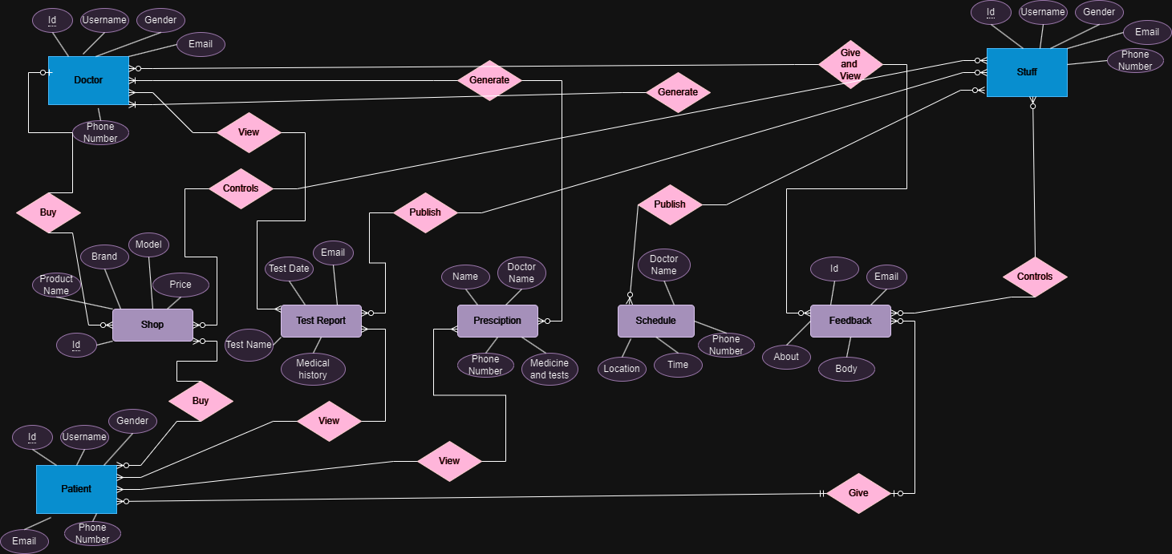

Tools Used:

To develop this project, we have used the following:

In this project we designed the front-end using HTML, CSS and a little bit of JavaScript. And for the back-end logics, we have used PHP, JavaScript ana AJAX ( Asynchronous JavaScript and XML)

And the software we used are :

• Visual Studio Code.

• Xampp Control Panel.

• Google Chrome. Or (Any web Browser).

• Subline Text.

System Images against the Specification:

Give few screen shots of some GUIs (project) and write a very small description (Maximum 40 words) for each of the GUIs.

The images are given in ascending order.

Mredul Mahmud

Md. Rifat Shikdar

Md. Zamiul Sadik Nahin

3 Pictures each person:

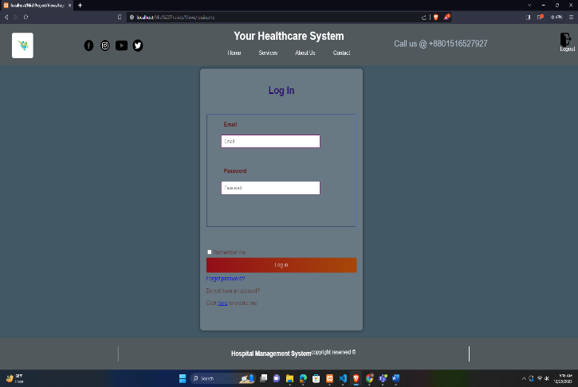

Impact of this Project:

* “The Healthcare Management System” is a platform that was created to help a combined group of people who are in need of healthcare. This platform is created by a hospital and this web application has 3 types of user. The motive of this web application is to get emergency consultation with doctor, for patients book a bed in advance, Buy medicines and pharmaceutical items in a digital way and get 10% discount on maximum items. The web application also provides an “Article” section and a “Q and A" section. By using them people from allover the community can ask about symptoms or they can get a primary treatment so that condition of a patient do not get much worse. And the article provides a ton of information about healthy lifestyle and provide information about several disease and ways to maintain them.”

Limitations and Possible Future Improvements:

Limitations include potential scalability issues with a growing user base and dependency on robust internet connectivity. Some of the billing properties need to be upgraded along with the payment method for shop. Future iterations may explore incorporating telemedicine features, expanding the virtual shop, and refining the user interface for a more intuitive experience and add more user-friendly cart system. The communication feature needs to be updated like with image and files also could be shared. Continuous user feedback and agile development practices will drive iterative improvements to ensure the web application remains cutting-edge and user-friendly.

*[Note: Make sure that your report is maximum 10 pages (including cover page). Print (Colored) the report and submit it with spiral bind.]*

|  |  |  |  |  |  |
| --- | --- | --- | --- | --- | --- |
| CO1.1 and CO2.1 Evaluation: Project Report Evaluation | | | | | |
| Project Proposal  (5) | Background  Study  (5) | Requirement Analysis  (5) | Entity  Diagram  (5) | System Images  against the  Specification (5) | Total (25) |
|  |  |  |  |  |  |
|  | | | | | |